# JS Advanced: Exam Preparation

Problems for exam preparation for the [“JavaScript Advanced” course @ SoftUni](https://softuni.bg/courses/javascript-advanced). Submit your solutions in the SoftUni judge system at <https://judge.softuni.bg/Contests/353/>.

## Table Builder (Object Interacting with DOM)

Write a **JavaScript function** to return a **table builder** object. It should take a **DOM selector** as **input** parameter and return as an **output** an object holding two functions: createTable(columnNames) and fillData(dataRows).

|  |
| --- |
| **function** *tableBuilder*(selector) {  *//* ***TODO: return { … }*** } |

The createTable(columnNames) **function** replaces the content in the target DOM element with a **new HTML table** holding a row with table headings given in the columnNames, and an additional column “**Action**”.

The fillData(dataRows) **function** puts in the table inside the target DOM element table rows holding the provided dataRows (array of arrays of strings). Add a **[Delete]** button in the last column. Clicking the **[Delete]** button should **delete** the entire table row.

Note that the table column names and table data cells may hold **special characters** that should be displayed as text.

### Examples

This is an example how the table builder function is **intended to be used**. Assume we have the following **HTML code**:

|  |
| --- |
| table-builder.html |
| <!DOCTYPE **html**> <**html**> <**head**>  <**title**>Table Builder</**title**>  <**style**>**td**,**th** { **background**:**#DDD**; **padding**:5**px** }</**style**>  <**script src="https://code.jquery.com/jquery-3.1.1.min.js"**></**script**> </**head**> <**body**> <**div id="main"**></**div**> <**script**>  **function** *tableBuilder*(selector) {  *//* ***TODO: return { … }*** } </**script**> <**script**>  $(**function**() {  let builder = *tableBuilder*(**"#main"**);  builder.createTable([**'Name'**, **'Town'**]);  builder.fillData([  [**'Maria'**, **'Sofia'**],  [**'Kiril'**, **'Varna'**],  [**'Ani <new>'**, **'Ruse'**],  ]);  }); </**script**> </**body**> </**html**> |

This is how the **HTML** and **DOM** should look like after the above code is loaded in a Web browser:

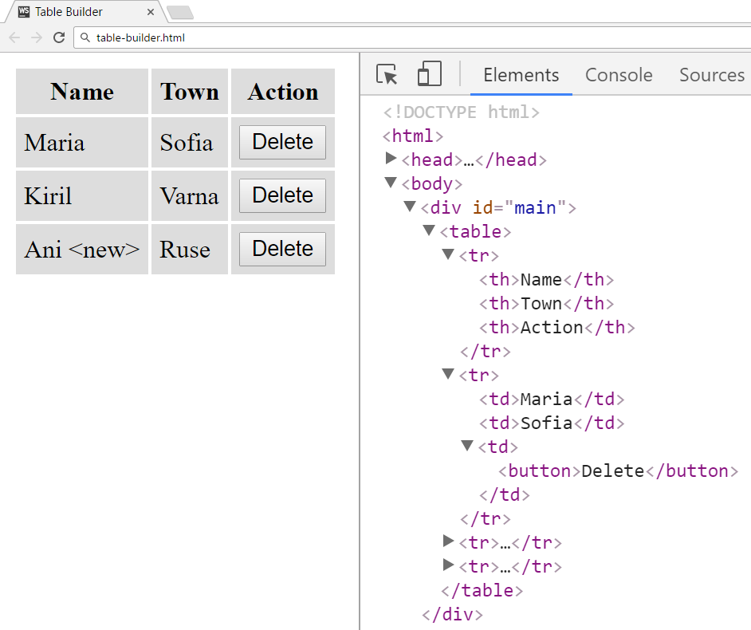

Clicking the **[Delete]** button at the row “**Kiril / Varna**” should delete this row:

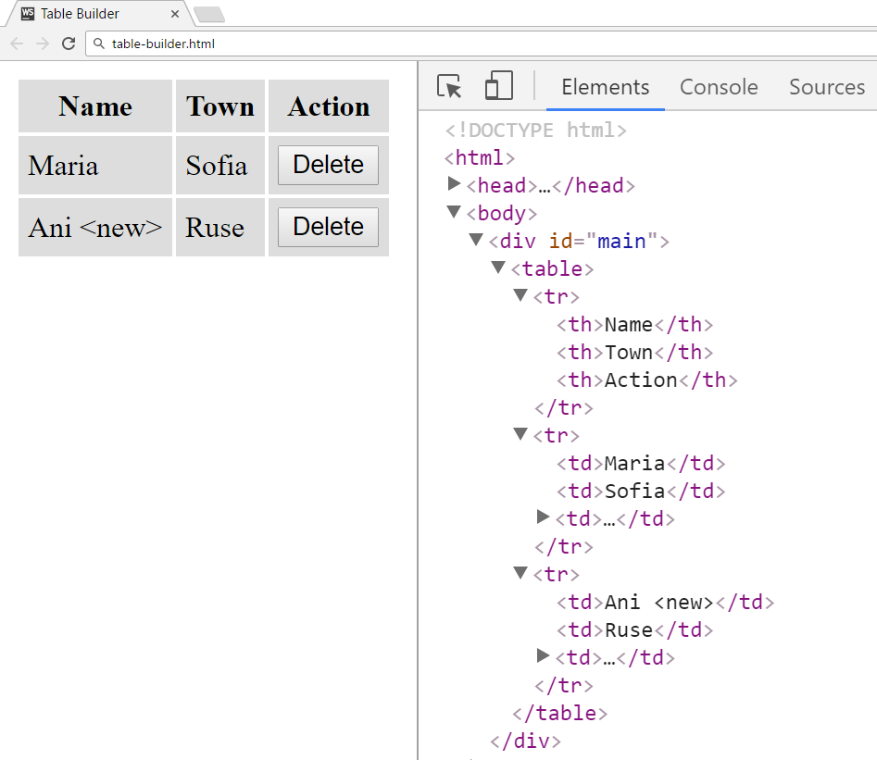

### Submission

Submit your tableBuilder function as “**JavaScript code (DOM unit tests)**”.